**GIT - Commends**

1. **git init**

Initializes a new Git repository in your current folder.

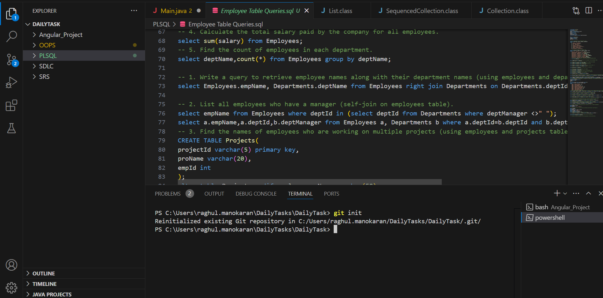

1. **git add .** Stages all modified, new, or deleted files, preparing them for commit.

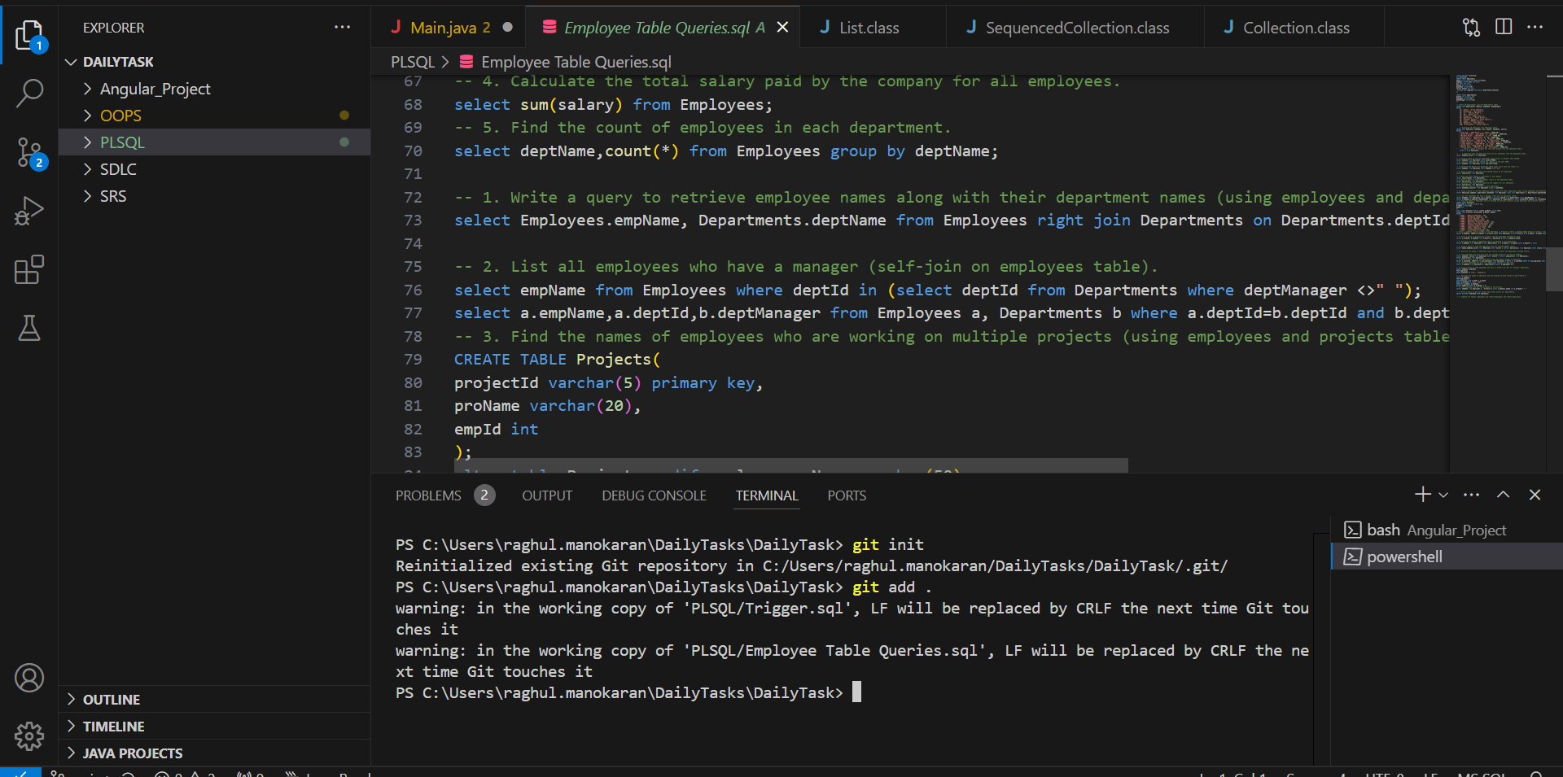

1. **git commit -m "SQL"**:

Commits the staged changes with a message "SQL".

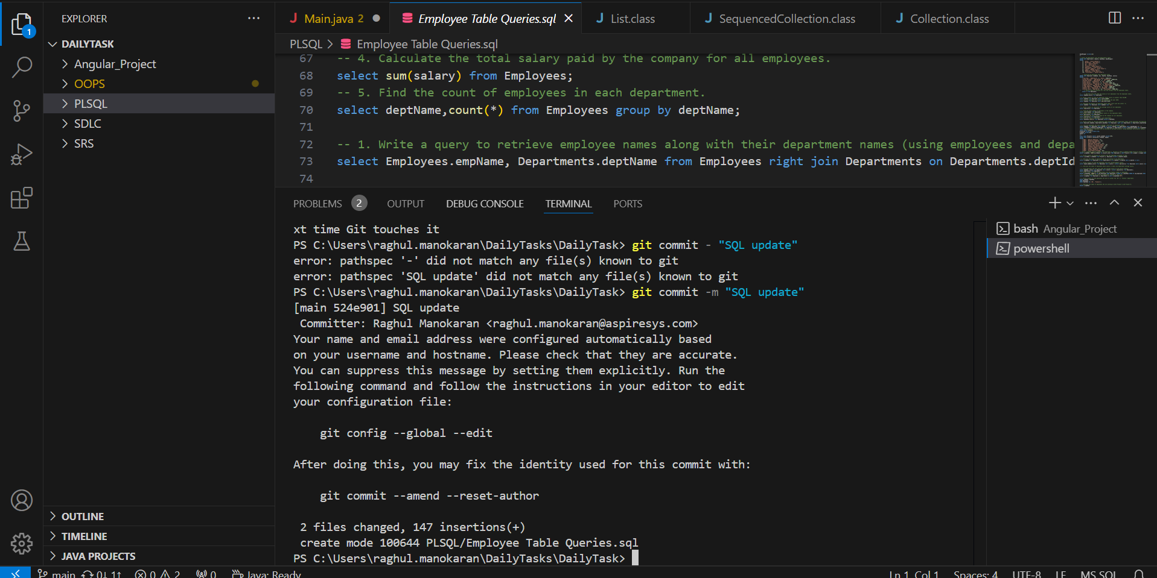

1. **git remote add origin** [**https://github.com/raghulsm2335/Tasks.git**](https://github.com/raghulsm2335/Tasks.git): Links your local repository to a remote repository on GitHub.

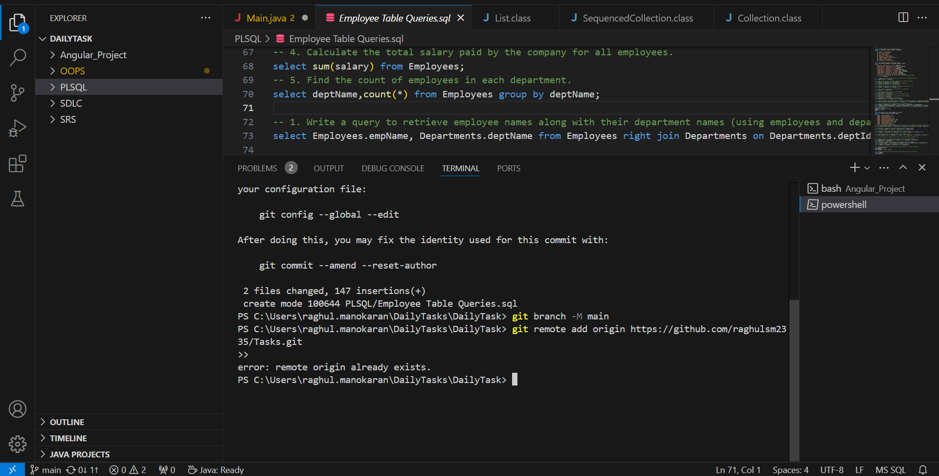

1. **git push -u origin main**:

Pushes your commits to the main branch of the remote repository and sets up tracking between your local main and the remote main.

